Title: Instagram Clone UI
Objective:

The objective of this project is to develop a mobile application that replicates the core features of Instagram, allowing users to view posts, interact with content, and explore media in a visually engaging way. The app focuses on providing a smooth and modern user interface with features such as login, feed, stories, reels, and profile management. It aims to enhance user experience and demonstrate mobile app development using Flutter.
Abstract not exceeding 300 words :

The Instagram Clone UI is a mobile-based application developed using Flutter to simulate the core functionalities of a social media platform like Instagram. The application provides a user-friendly interface where users can log in, view posts, interact with content, and explore reels.
The system consists of multiple modules such as user authentication (local login), feed display, stories section, reels interface, and profile management. Users can log in using basic credentials, after which they are redirected to the home screen. The feed displays posts with images, along with interactive options such as like and comment. The like button is enhanced with animation to improve user engagement.
The stories feature allows users to scroll horizontally through profile pictures, similar to Instagram. The reels module provides a vertical scrolling interface where users can view video-like content. The profile page displays user details along with a grid layout of posts.
The application is developed using Flutter and follows Material Design principles to ensure responsiveness and a modern look. Network images are used to simulate real-world content.
This project demonstrates how a social media UI can be designed efficiently using Flutter. It can be further enhanced by integrating backend services, real-time data storage, and multimedia uploads to create a fully functional social media application.
Innovation :

• Clean and modern Instagram-like UI design
• Interactive like button with animation
• Stories feature with horizontal scrolling
• Reels-style vertical scrolling interface
• Role-based navigation using bottom navigation bar
• Lightweight frontend-only implementation
• Uses real network images for realistic experience
• Can be extended with backend and real-time features.
Methodology Diagram:

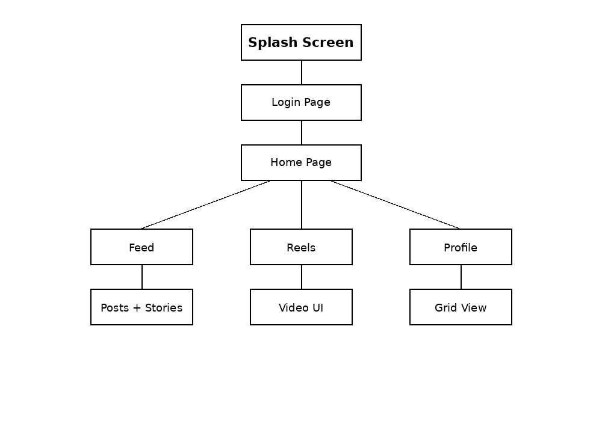

Working Principle:

The application begins with a login screen where the user enters a username and password. The system performs local validation to ensure that the fields are not empty. After successful login, the username is stored and passed to the profile section.
Once logged in, the user is directed to the home page, which includes bottom navigation for accessing different modules: Feed, Reels, and Profile.
In the Feed section, users can view posts displayed with images loaded from the internet. Each post includes interactive buttons such as like and comment. The like button includes animation for better user experience.
The Stories section is displayed at the top of the feed, allowing users to scroll horizontally through profile images.
The Reels section uses vertical scrolling to display video-like content in a full-screen format.
The Profile section displays the logged-in username, profile picture, and a grid layout of posts.
The application uses simple navigation and manages data locally, making it suitable for frontend demonstration purposes.

Screenshots :

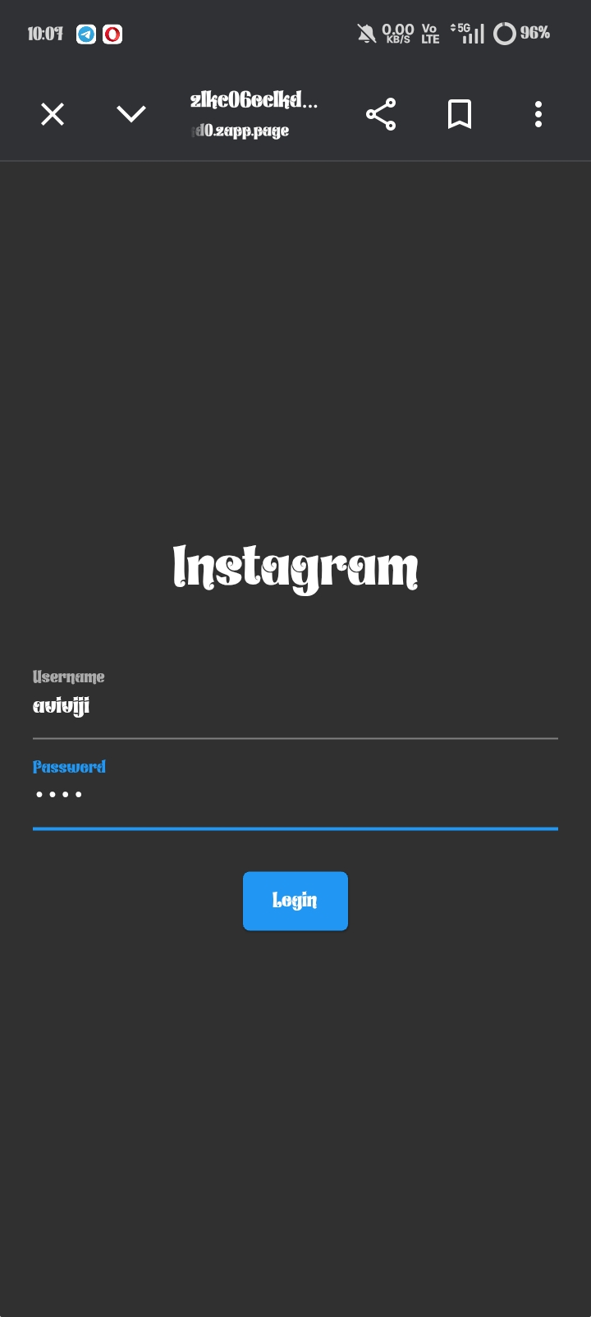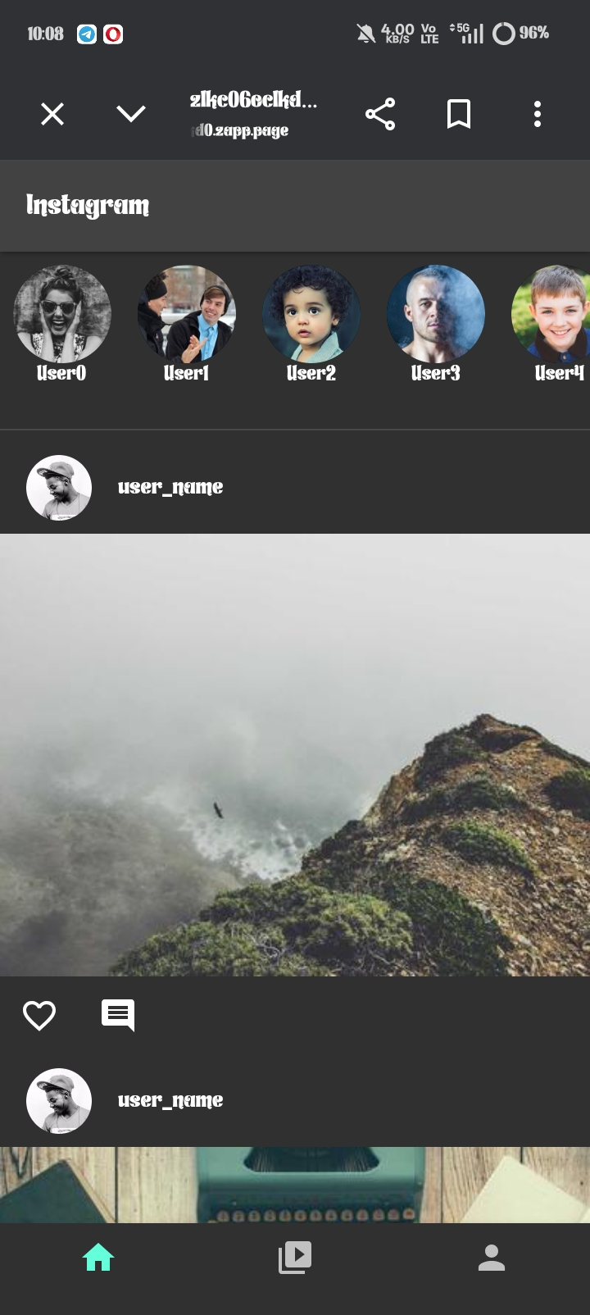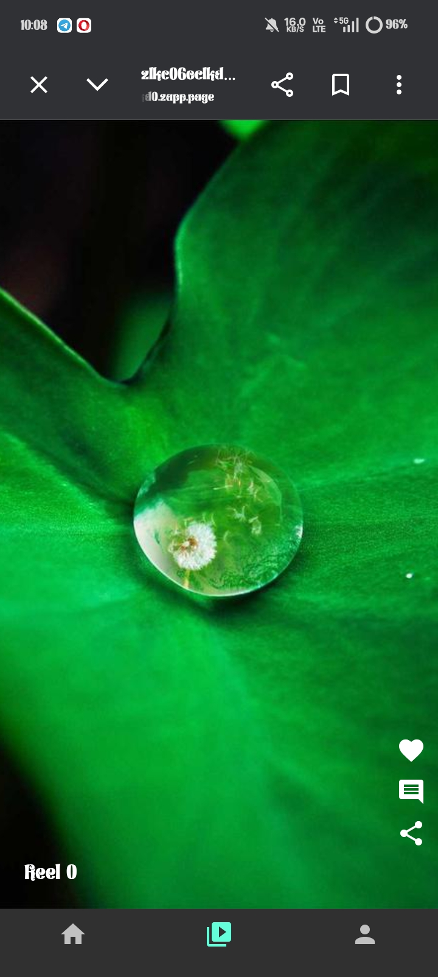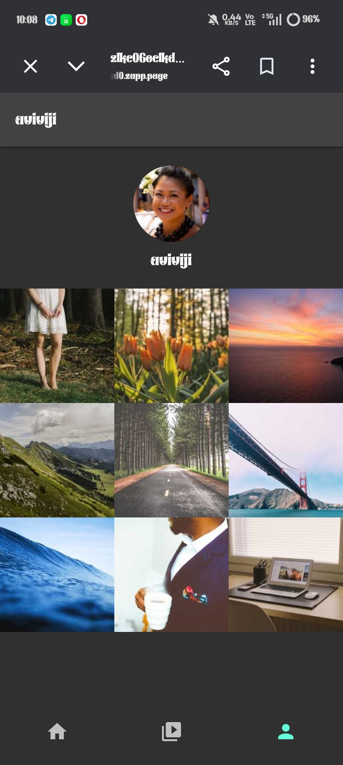

System Requirements:
H/W requirements:
• Computer / Laptop
• Minimum 4GB RAM
• Android Mobile Device / Emulator

S/W Requirements:
• Flutter SDK
• Dart Programming Language
• Android Studio / VS Code
• Web browser (Zapp / DartPad)

Outcomes Achieved :
• Developed a complete Instagram-like UI application
• Implemented local login system
• Designed responsive UI using Flutter
• Created feed, stories, reels, and profile modules
• Implemented animations for better user interaction
• Improved knowledge in Flutter UI/UX design
• Gained experience in navigation and state management
Application Areas:

• Social Media Applications
• UI/UX Design Prototyping
• Mobile App Development Learning
• Frontend Demonstration Projects
• Academic Mini / Final Year Projects

